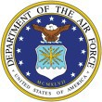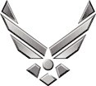
U N I T E D S T A T E S A I R F O R C E

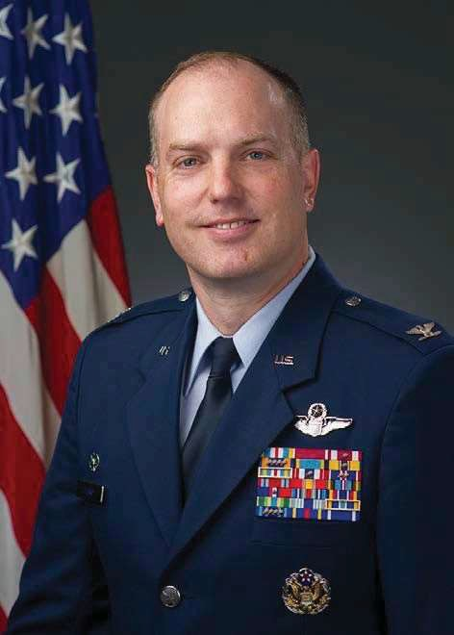
COLONEL MATTHEW A. LEARD
Col. Matthew A. Leard is the Chief of Staff, Headquarters Air Education and Training Command, Joint Base San Antonio-Randolph, Texas. As Chief of Staff, he is the principal advisor to the commander and deputy commander, and principal staff leader providing guidance and direction to eleven flying training wings, four technical training wings, a medical wing, Air University, two numbered Air Forces, nationwide recruiting operations and headquarters directors and chiefs of special staff across all functional specialties. He supervises implementation of command decisions, plans and policies for a staff of nearly 1,100 military members and civilian employees, and oversees the headquarters’ $255M budget.

Col. Leard is a 1998 graduate of Midwestern State University, in Wichita Falls, Texas. He earned his commission through Officer Training School in 1999. His assignments have included wing, squadron and detachment command and staff officer duties at Headquarters U.S. Transportation Command, Headquarters U.S. Air Force and Headquarters Air Mobility Command.

Prior to this position, Col. Leard was the Director of Pilot Training Transformation at Headquarters 19th Air Force. In this position he led a cross-command team responsible for the rapid modernization of the Air Force’s pilot training enterprise.

Col. Leard is a command pilot with more than 4,500 hours in the C-17A, C-21A, C-5M, KC-46A, KC-10, KC-135R, T-1A, T-6A and T-37B. His operational experience includes Expeditionary Airlift Squadron commander duties and numerous C-17A and C-21A combat missions in support of Operations Joint Forge, Joint Guardian, Northern Watch, Enduring Freedom and Iraqi Freedom.

EDUCATION
1998 Bachelor of Science Degree in Criminal Justice and Political Science, Midwestern State University, Texas
1999 Officer Training School, Maxwell AFB, Ala.
2000 Joint Specialized Undergraduate Pilot Training, Vance AFB, Okla. 2005 Squadron Officer School, Maxwell AFB, Ala. 2006 Program in Advanced Security Studies, George C. Marshall European Center for Security Studies, Garmisch, Germany
2010 Air Command and Staff College, by correspondence
2011 Master of Military Arts and Sciences, Air Command and Staff College, Maxwell AFB, Ala.
2012 Air War College, by correspondence
2019 Joint & Combined Warfighting School JPME-II, Joint Forces Staff College, Norfolk, Va.
2020 U.S. Air Force Enterprise Leadership Seminar, Kenan-Flagler School of Business, University of North Carolina, Chapel Hill

ASSIGNMENTS
- February 1999 - May 2000, Student, Joint Specialized Undergraduate Pilot Training, Vance AFB, Okla.
- August 2000 - June 2003, C-21A Instructor Pilot, Flight Commander and Scheduler, 86th Operations Group, Detachment 1, Stuttgart Army Air Field, Germany
- October 2003 - April 2007, C-17A Instructor Pilot, Executive Officer 437th Operations Group, Chief Operations Plans, Wing Plans, Assistant Chief of Tactics, 14th Airlift Squadron, Charleston AFB, S.C.
- April 2007 - June 2009, Programmer, Global Mobility Division, Deputy Chief of Staff, Plans and Programs, Headquarters
U.S. Air Force, Washington, D.C.
- June 2009 - June 2010, Execution Team Chief, Secretary of the Air Force and Chief of Staff Executive Action Group, Headquarters U.S. Air Force, Washington, D.C.
- July 2010 - June 2011, Student, Air Command & Staff College, Maxwell AFB, Ala.
- July 2011 - September 2012, Asst. Director of Operations, 14th Airlift Squadron, Joint Base Charleston, S.C.
- September 2012 - February 2013, Director of Operations, 15th AS, Joint Base Charleston, S.C.
- February 2013 - August 2014, Commander, 437th Operations Support Squadron, Joint Base Charleston, S.C.
- August 2014 - June 2015, Chief, Force Development, Headquarters Air Mobility Command, Scott AFB, Ill.
- June 2015 - June 2017, Chief, Commander's Action Group, Headquarters U.S. Transportation Command, Scott AFB, Ill.
- June 2017 - June 2019, Vice Commander, 60th AMW, Travis AFB, Calif.
- June 2019 – July 2021, Commander, 97th Air Mobility Wing, Altus AFB, Okla.
- July 2021 – June 2022, Director, Pilot Training Transformation, Headquarters 19th Air Force, JBSA-Randolph, Texas
- June 2022 – Present, Chief of Staff, Air Education and Training Command, JBSA-Randolph, Texas

FLIGHT INFORMATION
Rating: command pilot
Flight hours: more than 4,500 hours
Aircraft flown: C-17A, C-21A, C-5M, KC-46A, KC-10, KC-135R, T-37B, T-6A and T-1A

MAJOR AWARDS AND DECORATIONS
Defense Superior Service Medal Legion of Merit with oak leaf cluster
Meritorious Service Medal with oak leaf cluster Air Medal with four oak leaf clusters
Aerial Achievement Medal
Air Force Commendation Medal with oak leaf cluster Kosovo Campaign Medal
Global War on Terrorism Service Medal NATO Medal

EFFECTIVE DATES OF PROMOTION
Second Lieutenant Feb. 26, 1999
First Lieutenant Feb. 26, 2001
Captain Feb. 26, 2003
Major Oct. 1, 2008
Lieutenant Colonel Nov. 1, 2012
Colonel May 1, 2017

(Current as of June 2022)

