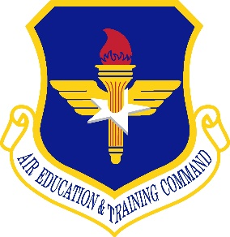

NEWS RELEASE

United States Air Force

Headquarters, Air Education and Training Command

Office of Public Affairs Phone: (210) 652-4400
100 H Street, Suite 4 Fax: (210) 652-2027
Joint Base San Antonio-Randolph, Texas 78150-4331 http://www.aetc.af.mil
Release Number: 20180131001
Date: Jan. 31, 2018

FOR IMMEDIATE RELEASE

19th Air Force Commander directs T-6 operational pause

JOINT BASE SAN ANTONIO-RANDOLPH, Texas – The 19th Air Force commander has issued an operational pause for all T-6 Texan II operations to ensure aircrew safety after a cluster of unexplained physiological events occurred at Columbus AFB, Mississippi, Vance AFB, Oklahoma, and Sheppard AFB, Texas within the last week.

Maj. Gen. Patrick Doherty directed the operational pause, beginning Feb. 1, to enable the Air Force to examine the root causes of the incidents, educate and listen to aircrew, develop and deliver mitigation solutions.

“The safety of our instructors and student pilots is paramount and has been our priority and focus,” said Maj. Gen. Patrick Doherty, 19th Air Force commander. “We’re acting swiftly, making temporary, but necessary, changes to everyone’s training, general awareness, checklist procedures, and possibly modify aircrew flying equipment to mitigate risk to the aircrew while we tackle this issue head-on to safeguard everyone flying T-6s.”

The Air Force established a general officer-led team to integrate and coordinate efforts across the Air Force to address aircrew Unexplained Physiological Events in early 2018. Brig. Gen. Bobbi Jo Doorenbos is leading the team and will work closely with 19th Air Force, AETC, and other MAJCOMs to examine the causes of these incidents and ensure industry and enterprise-wide solutions are given high priority to find root causes and deliver solutions across all weapon systems.

For more AETC Press Products, please go to:
http://www.aetc.af.mil/MediaRoom.aspx

- 30 -

